**Name : طه عزت بدر محمد**

**B.N: 432**

**Date : 10/7/2020**

**Topic:** **Artificial Intelligence**

**Application brief :**

**The reason I choose this research is due to its great importance in all areas of our lives where there are a lot of devices and machines that depend on it and the basis of its idea of it in a healthier sense as well as home networks and other things that are built on that.**

**This is a brief summary of the topic artificial intelligence is quickly remaking our world. The notable breakthroughs in the capabilities of artificial intelligence are that they reach a variety of innovations in addition to the independent vehicles and the network connected to the devices of things in our homes. Artificial intelligence also contributes to a controlled robotic arm in the brain that may facilitate the paralyzed person's feeling again through advanced human and brain interfaces. These new systems that support artificial intelligence revolutionize everything from trade and health care to transportation and cyber security.**

**Screeshots :**

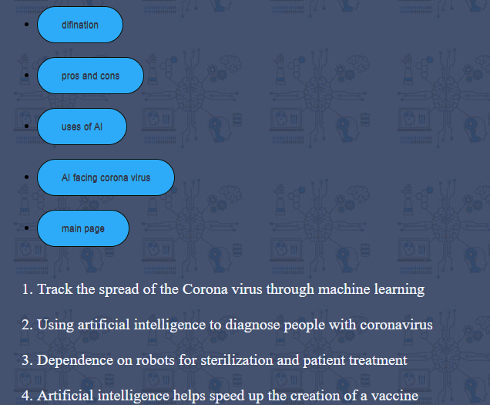

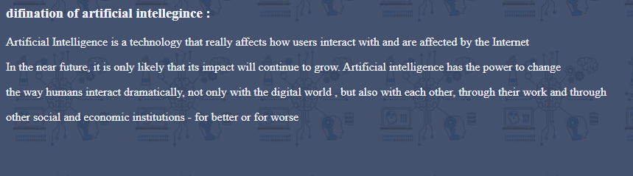

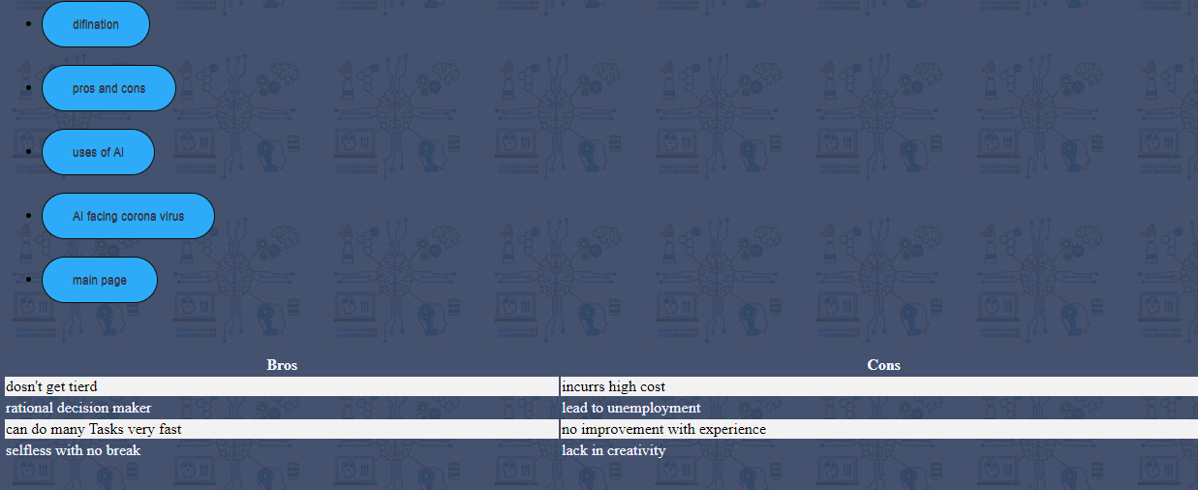

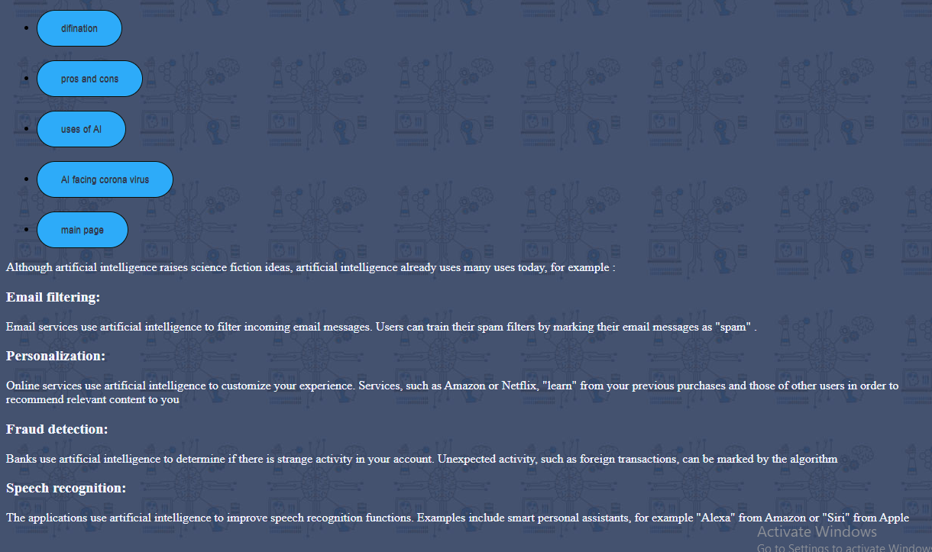

**Source code:**

